November12, 2020
@ArtReviewPower100: The “Really Big” Role of the Art Memer in 2020
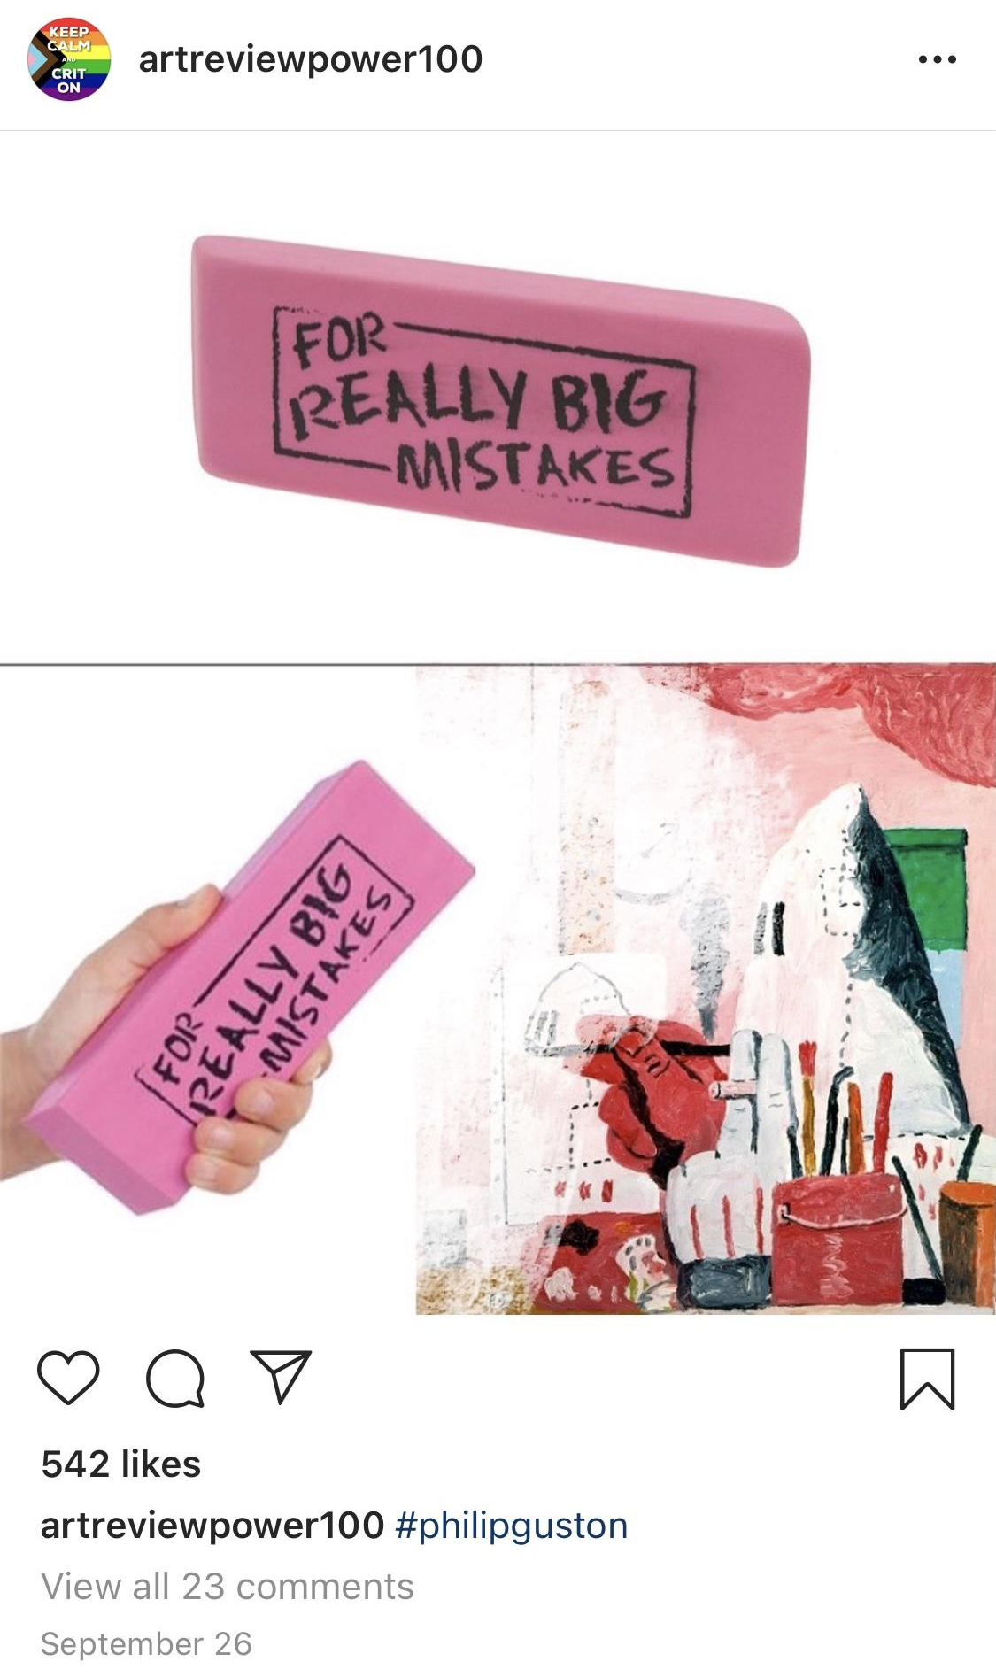

By Celia Glastris

@ArtReviewPower100 is an art meme account run anonymously which derives its name from the eponymous list by ArtReview Magazine of the most influential people in the art world. “I thought my account was the parody, but that list is a parody of itself,” said ARP100. Most of the individuals over the years that made the list are museum directors, collectors, gallerists, and only the occasional blockbuster artist. “It’s emblematic of everything wrong with the art world,” says the memer in an email. They declined the request to have an interview over Zoom or even a phone call over commitment to anonymity.
Five main art meme accounts come to mind–– @JerryGogosian, @Freeze_Magazine, @BradTroemel, @TheWhitePube, and @ArtReviewPower100. Each has its own particular audience and niche. @ArtReviewPower100, an account with almost 13,000 followers, more than others is geared towards the practicing artist, rather than arts workers, such as curators, museum workers, art directors, critics, and art historians. “Artists, art students, former art students, people who like art and want to feel like they are getting some inside knowledge. I think out of all the other art meme accounts that have popped up, this account is for the underdogs,” said ARP100. “The account has a long history of memes about failure, doubt, rejection, and depression. I think there’s something nice about knowing another person is struggling in the same way you are.”
ARP100 is an anonymous person who feels familiar. They post memes almost daily, which give a sense of their personality. It’s clear they’re an artist. “Yes. I have a studio where I make things that aren’t memes,” they say. The meme page has a tendency to joke about painting, which insinuates they are a painter, “I love painting and I relate to its history. I consider my work to be painting, but most others probably would not and that’s okay.” When asked what painting is, their response was, “painting is old, expensive, elitist, human, the greatest story ever told.” With some changes that threw out the element of romantic sentiment, the question was recycled into a meme the next day.
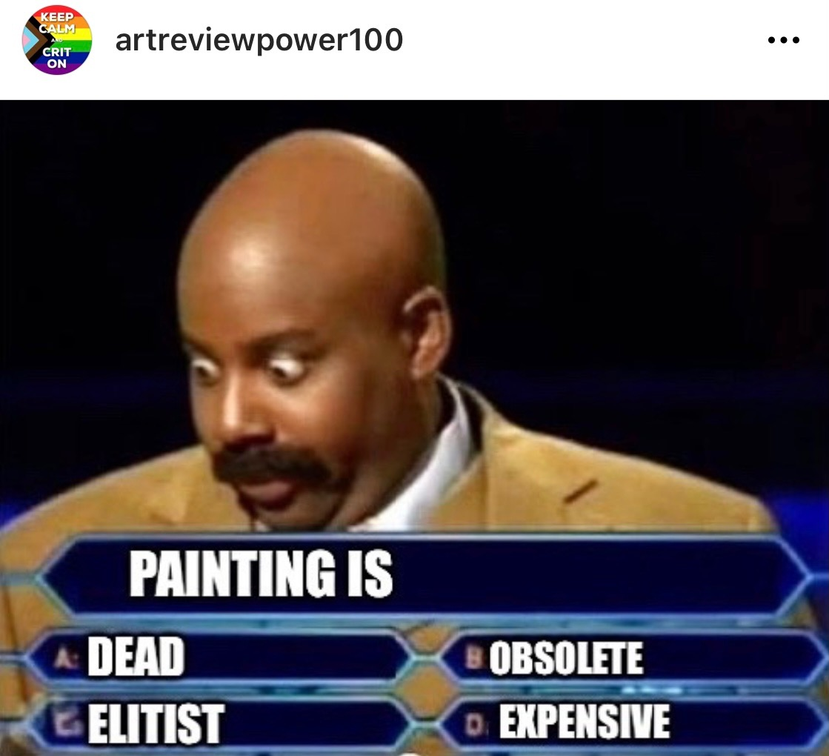
@ArtReviewPower100's October 16th, 2020 post following an email interview October 15th.

ARP100 started their meme page during their MFA back in 2014. The memer convinced their professor to allow the account to take place for a final term paper. The early posts of @ArtReviewPower100 were barely memes, they were low quality images of the individuals included in the Art Review Power 100 list with hashtag commentary. ARP100 was acting as a critic. It was a work of art in itself, embodying the debate about whether or not art memers can be critics, and perhaps if memes can be art. ARP100’s thoughts on the latter, “who cares, lol.”
ARP100 does consider themself to be an art critic, though. “It’s inherently snobby to call yourself a critic of anything”, they say, “but I think the anonymity and unpretentious meme format might make it okay.” Their prominence as a figure similar to an “art critic” or artist is a debated topic, but not new. Brad Troemel and Joshua Citarella have been writing about this for years, but the content has become exponentially more imperative since the pandemic.
The coronavirus has affected the art economy in every sector–– museum, gallery, institution, auction house, art fair–– which is a lot to process. Meanwhile, a generation of students are graduating into an unwelcome job market. Statistics consistently state that millennials and gen-z’s will face economic setback due to the coronavirus for the rest of their careers. An information desert generated through young people’s inability to gain knowledge at home without a job has made the Instagram art memer the interlocutor of artworld information from the top of the art pyramid to the young millennials and generation z’s fingertips.
@ArtReviewPower100’s spreads information about what it’s like to be a practicing artist today, and shares criticism safely under anonymity about the artworld and current topics. ARP100’s ability to surmise art and current art news into simple to digest art memes is what makes the page so great, and so useful. ARP100 shared a meme on September 26 of a giant eraser with “FOR REALLY BIG MISTAKES” printed onto it erasing Philip Guston’s Ku Klux Klan portrait, referring to the recent decision to cancel the painter’s major retrospective due to racial imagery. A follower in the comments asked, “Wait. Is this against Guston or the museums that have postponed openings?” ARP100 wrote back, “probably wrong time for it.”
Anonymity allows for art meme accounts like @ArtReviewPower100 to release criticism that may be crasser than what someone would feel comfortable publishing under their name, or what a publication would feel comfortable running. The boldness and ability to publish instantly allows news to spread that does not make it through art publications. Another one of ARP100’s memes satires two men at a panel discussion. “Imagine if contemporary discourse was suddenly relevant, unpretentious, and accessible to all…” says one. “Hav u heard of memes?” says another. It’s followed by a graph that correlates “the death of painting” with “the rise of memes.”
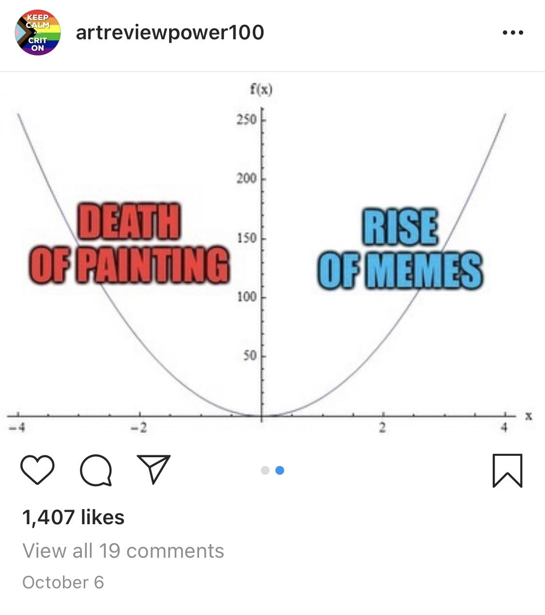
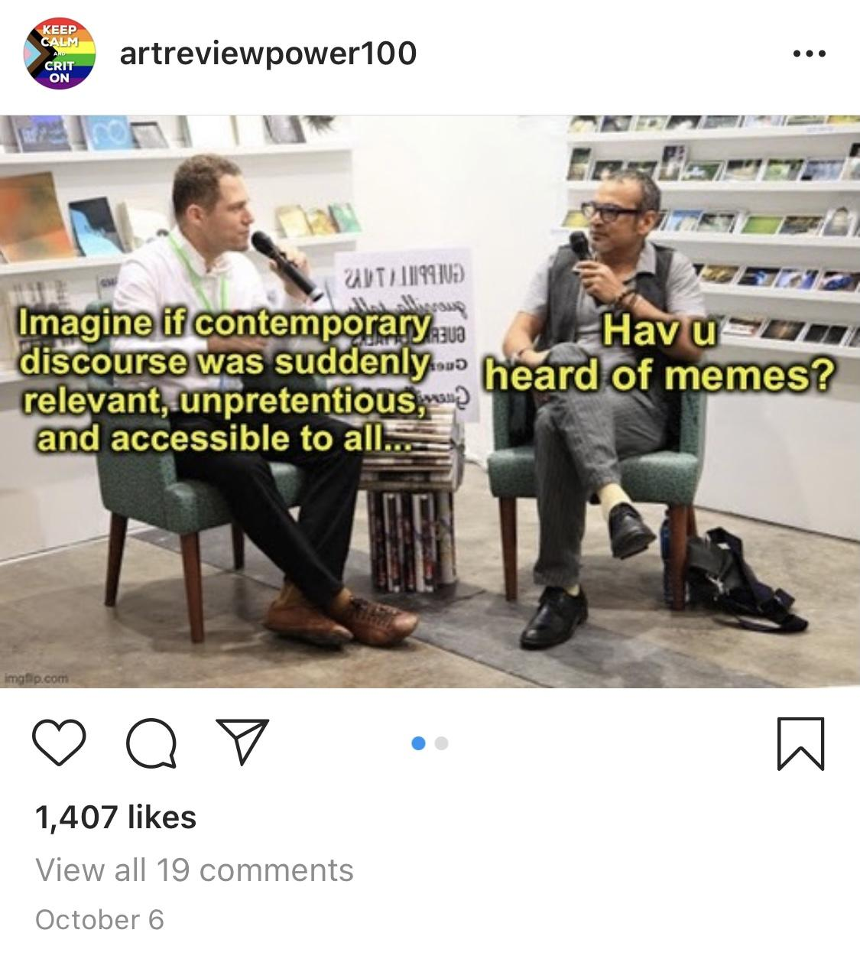
Art meme accounts like @ArtReviewPower100 are disentangling criticism from its elitist history and redistributing it to the masses. “Memes are in their infancy when compared against other histories like painting,” says ARP100. “Memes are like Facebook in the mid 2000s. To quote The Social Network, “We don’t even know what it is yet, we just know it’s cool.””

